**SECURE HOME AUTOMATION USING RASPBERRY PI BY TELEGRAM APP**

Mr. G. Nageswara Rao (ASSOCIATE PROFESSOR) 1

Gandham Harshitha (19K61A1215)2, Nimmala Akanksha (19K61A1240) 3,

Adapareddy Harika (19K61A1201) 4

1234DEPARTMENT OF INFORMATION TECHNOLOGY,

SASI INSTITUTE OF TECHNOLOGY & ENGINEERING, INDIA

**Abstract:** **A fundamental requirement of the modern home automation system is automated secure entrance. We suggest a secure home entry system utilizing the Internet of Things to meet this demand. The raspberry pi controller, camera, and other related sensors will be used in this proposal to try and build a smart, creative, and secure entry. The greatest approach to improve the home security system is to apply facial recognition, which has been done in our proposal. In the current approach, notifications are sent via Twitter or email. We are recommending a home security system that uses Telegram notifications due to the popularity and adaptability of using the current social network for all types of generation. Using the Telegram App for this project has the benefit of sending notifications to the user as it enables immediate, secure connection between the user and the home automation system.**

**Keyword: Raspberry pi , Open CV, facial detection, database, doorway, telegram.**

1. **INTRODUCTION**

A home automation system has several capabilities, including the ability to manage appliances like the washing machine, refrigerator, and air conditioner. One of the best ways to remotely operate household appliances is through the Internet of Things (IoT). Motion sensors and cameras are frequently utilised and operated by Raspberry Pi for surveillance purposes. A variety of sensors, including motion sensors and cameras, are used to create home security systems, and their detailed operation is displayed. IoT-based house and door automation has been built to notify the owner via Twitter or email.

an IR sensor is used in this system to detect any motion at the front entrance. When this happens, the camera is activated, the picture is taken, and it is sent to the owner by telegram. The door will automatically open if the database includes visitor picture information; otherwise, the owner will receive the image of an intruder and can decide whether or not to provide entrance In contrast to current notification methods, our suggested technique uses Telegram notification to alert the owner.

The advantage of using Telegram is that some elderly people avoid using Gmail and Twitter because they find those services cumbersome to use and need the creation of accounts. Most senior citizens prefer to use Telegram because it is a messaging app that functions online similarly to WhatsApp. This study proposal's main objective is to create and Use face detection and motion detection systems, which are also utilised for home automation, to create a low-cost, secure, and flexible home automation system that is capable of security. Secure home automation refers to the integration of security systems with home automation technologies to create a safe, secure, and smart home environment. With secure home automation, homeowners can remotely monitor and control their home security systems, as well as other smart devices such as lighting, temperature, and entertainment systems, from a single interface such as a smartphone or tablet.

1. **LITERATURE SURVEY**

Dey, Roy, and Das [1] People's everyday routines are being altered by technology. For example, an android app was built to assist elderly people who are unable to assist themselves, and this established system is utilised by people who live alone. This system implementation employs WIFI and a simple web server, both of which have the potential for future growth when joined with upgraded sensors to improve sensor precision (such as up to street Nights).

Sunehra and Ramana [2] Users can connect to the network at any time and control their household appliances as needed. This system also provides security by sending an email notification to the user if it detects an invader or person. A web page and a Telegram bot are used to operate the system.

Kadali, Prasad, Kudav, et al.[3] Home automation system that incorporates a variety of technologies, including the Internet of Things. The key advantage of this system is that it allows users to communicate via text as well as voice. For text input, a chat bot programme will be used, and for voice input, a voice assistant will be employed.

Biswas and Mynuddin [4] There are three levels of security assured. Use of NFC tags in conjunction with a PIR motion sensor and a password. If neither of them is there, the door will not open. The shaft of the servomotor that will be used to unlock the door is fitted with a lock. When a wrong password is entered, the LCD displays error text.

Kodali, Jain, Bose, et al. [5] People can live more comfortably thanks to the Internet of Things, which manages and interacts with remote control of home equipment. The proposed system has two Node MCUs. The Node MCU (Node micro controller unit) is an open-source device that combines hardware and software to build a much more affordable system based on the ESP8266 chip.

Dash and Choudekar [6] While an automated home can be referred to or categorised as a smart home, a wireless home automation system utilising the internet of things uses computers or mobile devices to run features automatically via the internet from anywhere on the planet. Nakrani, Panchal, Thakkar, et al. [7] These systems often include a detecting and actuation layer made up of passive infrared sensors, also referred to as motion sensors, and web cameras for security.

Reddy, Cheerla, Inthiyaz, et al. [8] This system makes use of equipment such as lights, fans, and camera access. Thanks to an Android software and a Telegram bot, any internet-capable device, such as a smartphone or laptop, may be used to operate home appliances. Furthermore, the proposed solution provides home security by employing a camera that may send photographs via Telegram bot message when no one is there.

Satapathy, Bastia, and Mohanty [9] To act as a connectivity module in order to demonstrate the system's effectiveness and viability. It allows the user to remotely handle a wide range of appliances, such as lights, fans, and televisions, as well as make decisions based on sensor feedback on various environmental parameters.

Rao, Vinod, Priyanka, et al. [10] The research focuses mostly on IoT-based home automation using a wireless Raspberry PI device. IoT allows us to control basic household equipment remotely from anywhere in the world using PCs or mobile devices..

Hema and Yadav [11] Everything nowadays travels at supersonic speeds, and digital media allows data to be transmitted at the speed of light. As a result, using Internet protocols, information must arrive at the same rate.

Desai and Pawar [12] In the current world, the Internet of Things is reaching its pinnacle. Home automation is becoming more popular as the world becomes smarter. Smart door control is one of the most recent home automation solutions. The goal of this research is to expand the door automation technology by using a Raspberry Pi and an Android mobile.

kh Shakthi and Abishiek et. al [13] A smart home is a networked combination of automation and administration that allows for exceptional living. In this regard, home security is critical, and it is becoming an important component of our lives.

Reeta [14] The facial recognition system works by first taking a photograph with a camera. The snippet of code recognises an individual's attributes. After being recognised, the shot image is compared to a photo database using a Raspberry Pi. The faces are then compared to see if they match. If an intruder tries to enter the premises, the SIM300 GSM module sends a security alarm to the specified person.

Pallavi et al. [15] Our initiative intends to develop simple-to-use gadgets such as home applications and other devices. We can control fans, air conditioners, lighting, and other appliances with an app on a cell phone running an Android, iOS, or Windows operating system.

Amri and Setiawan [16] The smart house was built on the foundation of email. This study looked at a home security system that recognises facial patterns to grant entry. This setup makes use of cameras and a BeagleBone. The system interacted with users via email.

Anvekar and Banakar [17] The database contains photographs of people who have been granted permission. When the person who rings the doorbell approaches the door, the camera records their face and compares it to previously recorded images in the database. If the image matches the one being captured at the time, the door unlocks. If it fails, the captured face is returned to the user.

Kumar and Mittal [18] In the event of a power outage, the system contains a backup. The backup power devices take the place of the primary supply and continue to power the security system.

Demir, S¸ ims¸ek, Gur, ¨ et al. [19] Their long-term goal is to develop an anonymous secure framework (ASF) for smart homes. To eliminate any problems caused by a compromised key, the ASF model relies on session key progression and routine key renewal. Although this paradigm provides unlinkability and anonymity, it lacks the feature of anonymous identification.

Taiwo and Ezugwu [20] The smart home is now a well-established field of study and research that contributes to modern-day comfort. With the Internet being such an important aspect of modern communication, IoT has enabled homes to evolve from simple structures to interactive environments. The Internet of Things has evolved enormously in many areas of human existence, including monitoring environmental conditions and controlling the home and its appliances.

1. **SECURE HOME AUTOMATION ARCHITECTURE**

To improve connection with the home security system, numerous extra modules such as image processing and Telegram are used in this design. We require both hardware and software codesign to create a secure home system. A microcontroller is required in hardware to regulate the overall operation of the system. LEDs and servo motors are employed as actuators. Sensors such as an infrared sensor and a Raspberry Pi camera are employed. The infrared sensor is used to detect motion. Raspbian Stretch is used to programme the Raspberry Pi controller, while OpenCV is utilised to process images. Telegram Messaging is used to communicate with and receive notifications from a home security system. The design of a complete secure home entry system.

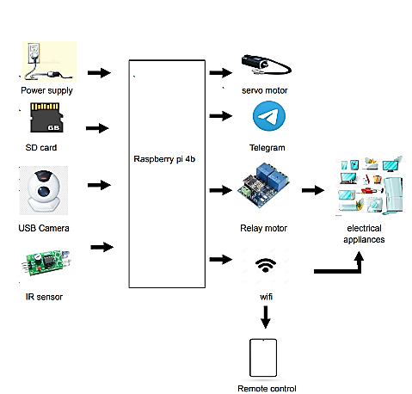

Figure 3.1: Architecture of Secure Home Automation

1. **METHODOLOGY**

Hardware requirements, software requirements, and user requirements are necessary for the proposed system's implementation design. Controlling the planned system's flow.

1. **Hardware Requirement**

The following hardware is needed for the proposed system to operate:

* 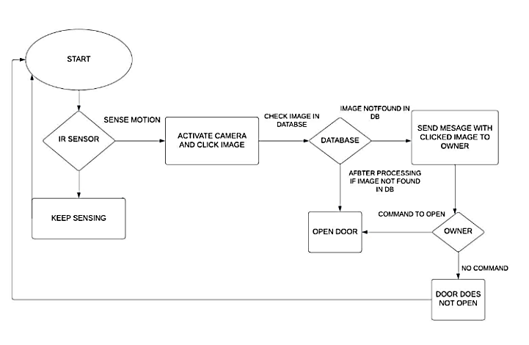Raspberry Pi Board : A computer the size of a credit card is the raspberry pi. It may be easily accessible, work as a regular desktop computer, and be utilised to create secure gadgets.

Figure 4.1: Control flow of Secure Door System

* USB Camera : The most common way for a camera to connect to a computer is by plugging it into a USB port. Using software, you can view the photographs on the computer after it gets the video feed and uploads them to the Internet.
* Sd card: Various portable devices, such as GPS navigation systems, cell phones, e-books, PDAs, personal computers, tablets, cameras, mp3 players, and digital video camcorders, can use Secure Digital cards for high-capacity storage.
* Servo Motor(door): This type of motor's control circuit frequently provides input on the motor shaft's current position, allowing the servo motors to rotate very precisely.
* Jumper wires: To connect distant locations, a jumper wire, an electric cable, is utilised. printed circuit boards with electric circuits.

1. **Software Requirement**

The following applications, all of which are open source, are necessary for the proposed work:

* Raspbian Stretch : Raspbian Stretch is a computer operating system for Raspberry Pi that is based on Linux. Along with Raspbian Stretch and Raspbian Jessie, there are numerous Raspbian iterations.
* Open cv: Open cv is a computer vision library built on Python that is utilised in image processing.

1. **Other Requirements**

The user needs the user requirements, which are among the most crucial criteria for using this system**.**

* Telegram: Similar to WhatsApp or Facebook Messenger, Telegram is a chat service that operates online. That implies we can use a Wi-Fi connection or a mobile data plan to send and receive texts. It is used to send and receive messages, images, and videos on the Raspberry Pi since it offers strong security features.

1. **METHODOLOGY**

The following steps illustrate the proposed system's operation step by step:

**Step1: Database** - This displays the photographs of those whose identities have been verified to enter the residence.

**Step 2: Start-up of Secure Door –** The user has the option to keep the security system OPEN or CLOSE depending on whether he is at home or not. The monitoring system is activated when the Telegram user types the command "start". "BOT STARTED Notification" message is then sent by the home security system in response. This can be done by the owner whether he is at far from his place or at work place with the help of application which will be available in his phone

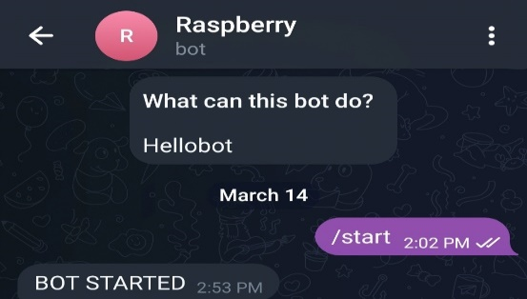

Figure 4.2: Snap shot of Start-up of System as shown in Telegram application

**Step 3: Object Identification using IR Sensor -** When an IR sensor detects movement close to the door, the camera is turned on. When turned on the camera records a picture of the person waiting in front of the entrance for monitoring.

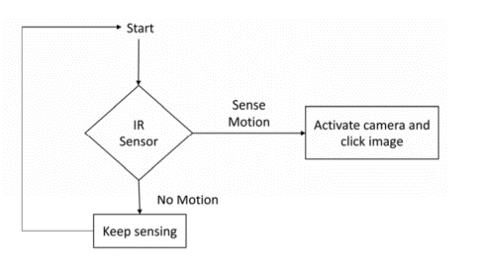

Figure 4.3: Object Identification

**Step 4: Identification of Person -** When an image is clicked, facial recognition is performed using the image that was previously stored in the database. For authenticated individuals, the door will open, and for unauthorised individuals, the home's owner will be notified**.**

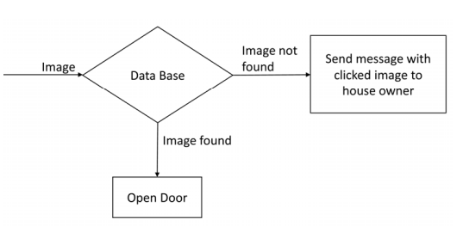

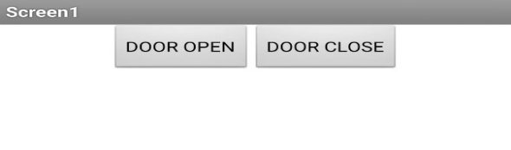Figure 4.4: Check image in Database

**Step 5: Door Action – Authenticated** individuals are permitted entry, and the owner is informed in full about each individual. The Raspberry Pi is manually given the open command by the home's owner in order to open the door automatically if the owner wants to let someone inside who is not listed in the database. The owner opens the door with the 'Open' command. the Raspberry Pi responds to the aforementioned command by displaying the message "open door!" to inform the owner of the door's condition. And the door opened

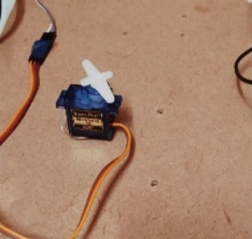

Figure 4.5: Opened door operation of system

When any unauthorized person is trying to entry the home then door won’t open and the door and in response “UNAUTHORIZED PERSON TRYING TO ACCESS PSW!” message is shown on the Telegram

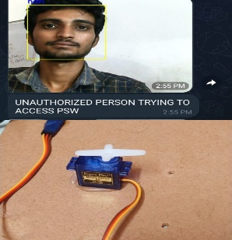

Fig 4.6 Unauthorised alert Message

**Step 6: Load Control -**This system uses a mobile app for controlling load with help of relays for example when the owner is away from home but the load appliances like ac and geyser are “ON” at home then owner can access them form anywhere.

**Step 7: Manual Access-**This system uses a manual access if the person is unidentified and should to allowed in by owner then he can access the door by selecting operations.

Figure 4.7: Manual Operation

1. **HAAR CASCADE CLASSIFIER IN OPENCV**

* OpenCV provides the trainer as well as the detector. We can train the classifier for any object like cars, planes, and buildings by using the OpenCV. There are two primary states of the cascade image classifier first one is training and the other is detection.
* OpenCV provides two applications to train cascade classifier opencv haartraining and opencv raincascade. These two applications store the classifier in the different file format.
* For training, we need a set of samples. There are two types of samples:
* Negative sample: It is related to non-object images.
* Positive samples: It is a related image with detect objects.
* Negative samples are taken from arbitrary images. Negative samples are added in a text file. Each line of the file contains an image filename (relative to the directory of the description file) of the negative sample. This file must be created manually. Defined images may be of different sizes.
* Positive samples are created by opencv create samples utility. These samples can be created from a single image with an object or from an earlier collection. It is important to remember that we require a large dataset of positive samples before you give it to the mentioned utility because it only applies the perspective transformation.
* OpenCV already contains various pre-trained classifiers for face, eyes, smile, etc. Those XML files are stored in opencv/data/haarcascades/ folder. Let's understand the following steps:
* First, we need to load the necessary XML classifiers and load input images (or video) in grayscale mode.
* After converting the image into grayscale, we can do the image manipulation where the image can be resized, cropped, blurred, and sharpen if required. The next step is image segmentation; identify the multiple objects in the single image, so the classifier quickly detects the objects and faces in the picture.
* The haar-Like feature algorithm is used to find the location of the human faces in frame or image. All the Human faces have some common universal properties of faces like the eye region is darker than it's neighbor's pixels and nose region is more bright than the eye region.
* In this step, we extract the features from the image, with the help of edge detection, line detection, and center detection. Then provide the coordinate of x, y, w, h, which makes a rectangle box in the picture to show the location of the face. It can make a rectangle box in the desired area where it detects the face.
* The face recognition is achieved by calculating the Euclidean distance between feature vectors of a probe and reference image. This method is effective in illumination change by its nature, but it has a considerable drawback. The correct registration of the maker is very hard.
* The face recognition algorithm is used in finding features that are uniquely described in the image. The facial image is already extracted, cropped, resized, and usually converted in the grayscale.
* A face recognition door lock system is a security system that uses facial recognition technology to identify authorized individuals and grant them access to a locked area or door. The system captures an image of the person's face, compares it to a database of authorized individuals, and unlocks the door if there is a match. The system can be used in various settings, including homes, offices, and public spaces, to enhance security and prevent unauthorized access.
* The system is reliable and convenient, eliminating the need for traditional keys or access cards, and reducing the risk of security breaches.

1. **CONCLUSION AND RESULTS**

The Internet of Things and image processing are two cutting-edge technologies that are used in this idea for a high level of security. The suggested work is implemented utilising a Raspberry Pi, which can connect to a computer or a mobile device, making it simple for the user to utilise. Our technology is an integration of all the previous work in which an IR sensor is utilised to detect objects, which then activates a camera to detect faces. The technology is made to allow secure remote access and control of home equipment.

1. **FUTURE SCOPE**

The proposed system can be used as a Smart Surveillance Monitoring security system by utilising the Raspberry Pi. Since open cv is being utilised in our project, it can be used to construct a class attendance system. Therefore, no one is permitted to mark another student's proxy. The technology is adaptable, and the suggested work makes upgrading simple. With an upgrade, a secure home will become a smart home, which means we won't have to give the system commands repeatedly. Understanding human needs and controlling the home in accordance with them are crucial roles played by artificial intelligence. This suggestion can be expanded to include smart card switching, fingerprint recognition, alcohol detection, and many other features to create a highly advanced system.

1. **REFERENCES**

[1] S. Dey, A. Roy, and S. Das, “Home automation using internet of thing,” in 2016 IEEE 7th annual ubiquitous computing, electronics & mobile communication conference (UEMCON), IEEE,2016, pp.

[2] D. Sunehra and G. V. Ramana, “Webpage and telegram bot controlled home automation system using raspberry pi3,” INTERNATIONAL JOURNAL OF SCIENTIFIC & TECHNOLOGY RESEARCH, vol. 9, no. 02, 2020.

[3] B. Kadali, N. Prasad, P. Kudav, and M. Deshpande, “Home automation using chatbot and voice assistant,” in ITM Web of Conferences, EDP Sciences, vol. 32, 2020, p. 01 002.

[4] P. Biswas and M. Mynuddin, “Design and implementation of smart home security system,”

[5] R. K. Kodali, V. Jain, S. Bose, and L. Boppana, “Iot based smart security and home automation system,” in 2016 international conference on computing, communication and automation(ICCCA), IEEE, 2016, pp. 1286–1289.

[6] S. Dash and P. Choudekar, “Home automation using smart devices and iot,” in 2021 9th International Conference on Reliability, Infocom Technologies and Optimization (Trends and Future Directions)(ICRITO), IEEE, 2021, pp. 1–5.

[7] V. Nakrani, M. Panchal, D. Thakkar, S. Pednekar, and Y. Mane, “A review: Internet of things (iot) based smart home automation,” International Journal of Recent Trends in Engineering and Research, vol. 3, no. 3, p. 231, 2017.

[8] V. S. Reddy, S. Cheerla, S. Inthiyaz, V. Chakravarthy, and V. G. Ram, “Face recognition and home automation using telegram bot,” in AIP Conference Proceedings, AIP Publishing LLC, vol. 2407, 2021, p. 020 004.

[9] L. M. Satapathy, S. K. Bastia, and N. Mohanty, “Arduino based home automation using internet of things (iot),” International Journal of Pure and Applied Mathematics, vol. 118, no. 17, pp. 769–778, 2018.

[10] G. Rao, A. Vinod, N. Priyanka, C. H. Kumar, et al., “Iot based web controlled home automa tion using raspberry pi,” International Journal of Scientific Research in Science, Engineering (IJSRSET), vol. 6, no. 2, pp. 229–234, 2019.

[11] N. Hema and J. Yadav, “Secure home entry using raspberry pi with notification via telegram,” in 2020 6th International Conference on Signal Processing and Communication (ICSC), IEEE, 2020, pp. 211–215.

[12] S. Desai and V. D. Pawar, “Smart door security system using raspberry pi with telegram,” Int. Res. J. Eng. Technol, vol. 6, no. 6, pp. 1400–1404, 2019.

[13] S. M. KH, K. Sumathi, V. Mano, I. M. Elias, and S. M. Raj, “Advanced smart home security alert system,”

[14] R. Reeta, “Smart secure door lock system using iot and eigenface approach,” IJCRT, vol. 5, no. 4, pp. 2414–2418,

[15] K. Pallavi et al., “Controlling smart home appliances using raspberry pi,” Turkish Journal of Computer and Mathematics Education (TURCOMAT), vol. 12, no. 12, pp. 3105–3109, 2021.

[16] Y. Amri and M. A. Setiawan, “Improving smart home concept with the internet of things concept using raspberry pi and node mcu,” in IOP Conference Series: Materials Science and Engineering, IOP Publishing, vol. 325, 2018, p. 012 021.

[17] R. G. Anvekar and R. M. Banakar, “Iot application development: Home security system,” in 2017 IEEE Technological Innovations in ICT for Agriculture and Rural Development (TIAR), IEEE, 2017, pp. 68–72.

[18] R. Kumar and P. Mittal, “A novel design and implementation of smart home security system: Future perspective,” International Journal of Applied Engineering Research, vol. 14, no. 2, pp. 363–368, 2019.

[19] S. Demir, S¸ . S¸ ims¸ek, S. Gur, and A. Levi, “Secure and privacy preserving iot gateway for ¨ home automation,” Computers and Electrical Engineering, vol. 102, p. 108 036, 2022.

[20] O. Taiwo and A. E. Ezugwu, “Internet of things-based intelligent smart home control system,” Security and Communication Networks, vol. 2021, pp. 1–17, 2021